
https://atlas.cid.harvard.edu/

Optimal Industry Development Strategy Using Economic and Product Complexity

Egypt

─
The Economic Complexity Lab - Columbia University
Alexandra Garcia, Margarita Demkina, Kelly Mi, Allison Lin, Helena Yang, Jane Zhang, Daniel Xu, Ryo Shibata, Haoxian Chen, Davepriyan Gunaratnam, Rohan Macherla, Ajit Akole, Shomik Ghose, Alex Wei-Liang Ku, Sannidhya Modi, Xilin Wang
Optimal Industry Development Strategy for Egypt

0. Executive Summary

In this report, we aim to uncover the economic path Egypt went through during the period from 2013 to 2021. Specifically, we dive into the topic through a macroeconomic overview of Egypt from the perspective of Gross Domestic Product (GDP) and Economic Complexity Index (ECI), which reflect countries’ production capability and production structure, respectively. We find that for the period between 2013 and 2018, Egypt demonstrated a moderate level of economic growth with an annual GDP growth rate of -2.33%, concurrent with a slight decrease in economic complexity as compared with other major emerging economies. For the period between 2019 and 2021, the average GDP growth rate was 10.39%, concurrent with a 220.96% increase in economic complexity.

The level of economic progress during the period, we believe, can be partially explained through analysis of the economic and product complexity structure of Egypt at the industry group level. The product classification system we adopt allows us to measure the realized industry development for various industry groups and to observe that Egypt invested heavily in developing Animals and By-products and Machinery and Construction during the years of 2013-2018, while its emerging peers and developed economies around the globe adopted much more complex and progressive paths. By 2021, Egypt focused on High Complexity Products and achieved a higher ECI.

Based on our analysis of the opportunity gain and a sensitivity analysis of major industry groups, Egypt could have furthered its gains by prioritizing Daily Instruments and Services and Utilities in 2018. Three years later, in 2021, its focus should have shifted to the Energy Drilling and Mining and Clothing and Accessories industries. We further note that Egypt has a moderately matched development strategy that indicates a moderate level of structural optimality at the complexity level, with an adjusted R-square of around 4.9% in 2018 and -3.0% in 2021. Since a significant positive correlation exists between GDP growth and the structural optimality index of an economy as we define and calculate, Egypt indeed has a suboptimal growth experience as compared with fast-growing economies both on a regional scale and on a global scale, and has the potential to further its economic gains through industrial structure optimization as suggested in the paper.

1. Report Overview

In this report, we aim to uncover the economic path Egypt went through during the period from 2019 to 2021, before and after the COVID pandemic, compared to its performance from 2013 to 2018. Specifically, we dive into the topic through a macroeconomic overview of Egypt from the perspective of Gross Domestic Product (GDP) and Economic Complexity Index (ECI), which reflect countries’ production capability and production structure, respectively. We then analyze the industrial framework and changes of Egypt during the period based on quantitative measures such as the Product Complexity Index (PCI) and Product Family Complexity Index (PfCI), followed by a detailed analysis of how such changes have matched with development strategies as quantitatively measured by opportunity gains on an industry-level. We conclude our report with macro-level results and predictions of Egypt, as deduced from regression models we have established on a global scale, which take into account countries’ stances in their product space.

2. Macroeconomic Results

2.1 GDP Ranking and Changes
As the largest economy in Africa by GDP, Egypt had a GDP of 288 billion USD in 2013 and 250 billion USD in 2018, exhibiting a promising level of economic output. Figure 1 illustrates the time-series GDP results for top African countries from 1999-2018, and Egypt ranks among its counterparts as a major African economy. In particular, the period from 2013 to 2018 seems to be a rather unstable period for Egypt in terms of GDP growth as compared with its emerging peers. During the five years, Egypt exhibited an annual GDP growth of -2.33%, much below the annual growth rates of the other three leading African economies, which had an arithmetic average growth rate of 0.51%. The negative performance of GDP during the period, we believe, can be reflected through changes in ECI and PCI, and can be further explained by the production strategies adopted by Egypt during the period, which we will expand on in the later stage of the report.

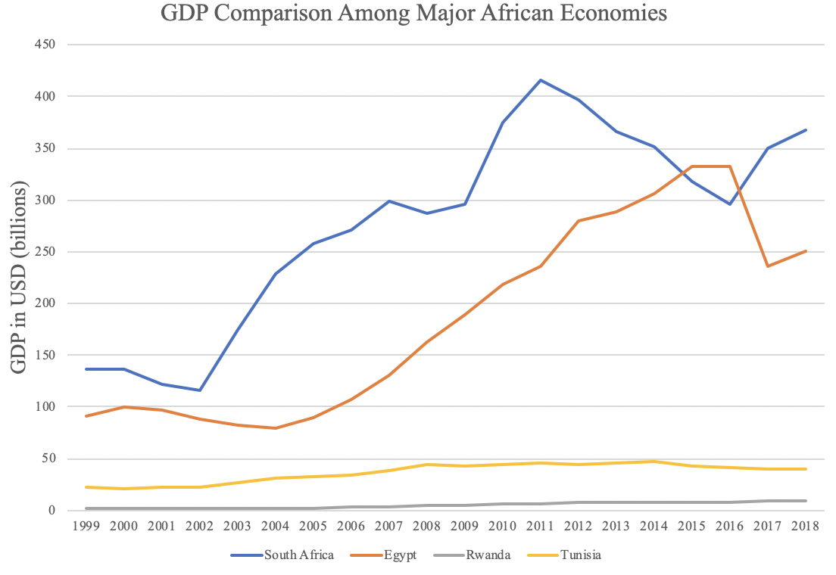

Figure 1a: GDP Comparison Among Major African Economies

Figure 1b shows the GDP levels for Egypt and its peer countries (South Africa and Tunisia) from 2019 to 2021. Unlike its peer countries, Egypt displayed consistent and significant growth in GDP from 2019 to 2021. Over these three years, Egypt’s average annual GDP growth rate (10.39%) is higher than its peers’ (3.89% for South Africa and 3.98% for Tunisia).

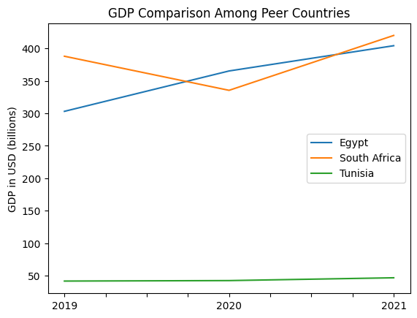

Figure 1b: GDP Comparison Among Peer Countries

2.2 ECI Ranking and Changes
The Economic Complexity Index (ECI), as defined by Ricardo Hausmann and Cesar Hidalgo in 2009 to explain the knowledge accumulated in a country's population, exhibits a similar pattern for Egypt. As illustrated in Figure 2a below, Egypt exhibits a negative trend in terms of its production capability from 2013 to 2018, as measured by ECI. This is in direct contrast to countries such as Tunisia, which demonstrate an advantage as compared with Egypt in terms of both GDP and ECI indicators.

The comparable countries exhibit greater changes in ECI level between 2019 and 2020, especially between 2020 and 2021. Egypt exhibits a large increase in production capability in 2021 to levels not seen prior, likely due to government efforts and financial support from the IMF to aid in post-pandemic economic recovery.

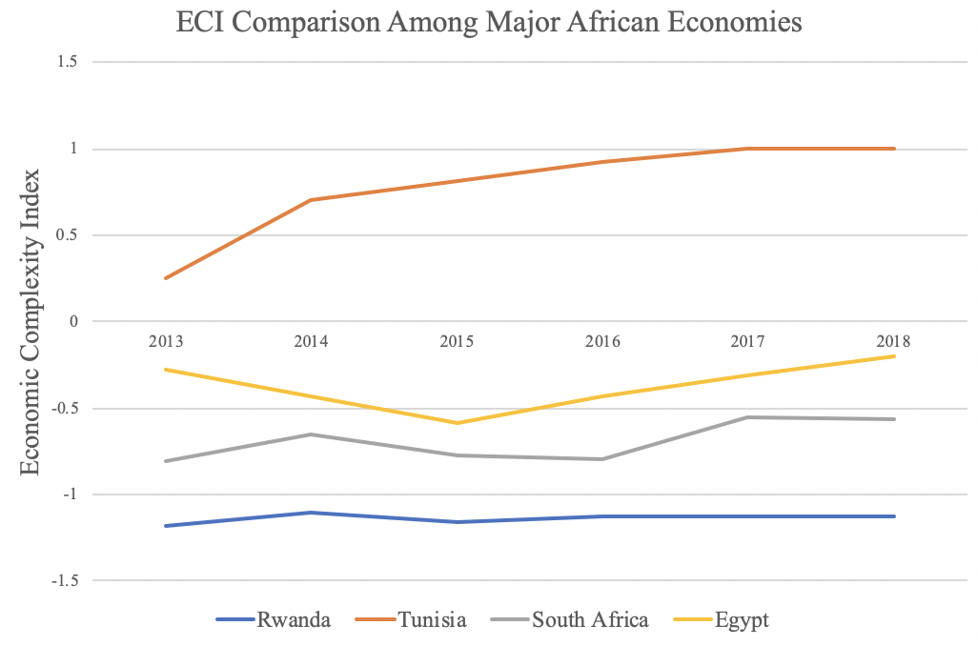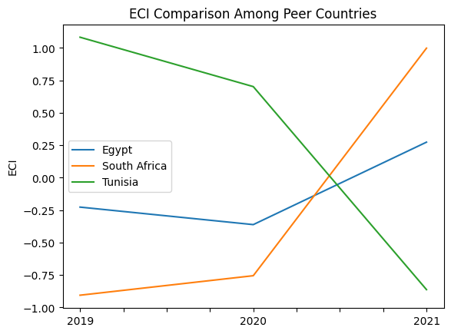

Figures 2a and 2b. ECI Comparison Among Peer Countries (left: 2013-2018; right: 2019-2021)

Figures 3a and 3b offer a further comparison of GDP Growth and ECI over the time span from 2013 to 2021 for Egypt. For both 2013-2018 and 2019-2021 periods, there is a notable ECI drop and further increase. Unlike the similarly volatile decrease in GDP for 2013-2018, however, ECI volatility in 2019-2021 is accompanied by relatively stable GDP growth. The results show that the economic growth experienced by Egypt during the period from 2013 to 2018 is only partially consistent with the predictions by ECI and that Egypt made moderate progress towards effectively developing a competitive product space that helps to accumulate complicated knowledge and technology. For the period 2019 to 2021, the overall increase in ECI and GDP can be interpreted as positive-return advancements in production. In order to provide a more concrete answer to why this has happened, we will dive into an analysis of Egypt’s production structure and its product space designs in the next few sections.

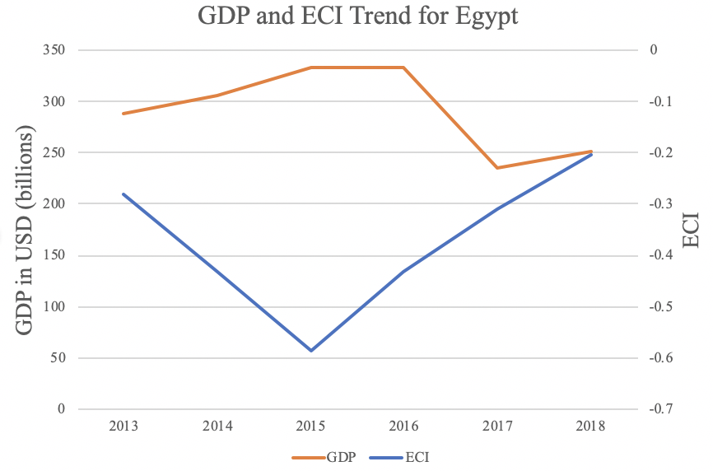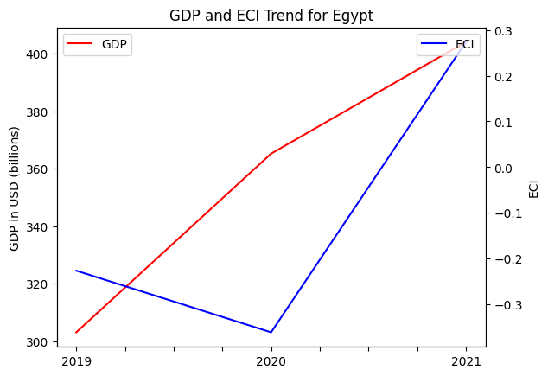
Figures 3a and 3b. GDP Growth and ECI for Egypt (left: 2013-2018; right: 2019-2021)

3. Production Analysis

3.1 Product Categorization
Our main data source in this research is the UN Comtrade Website (https://comtrade.un.org), which provides us with valuable information on countries’ export values on an annual basis, including highly specific export data for more than 5,000 categories of products. In order to have a holistic vision of the product space of a country, however, a level of categorization is required. Products in our data source are labeled from 010000-999999, with the first two-digits representing a general category to which the product belongs. Based on the 99 categories as extracted from the label, we further group the products into 18 most widely-accepted industries, as summarized in Table 1.

Note that the High-complexity Products industry group is not a distinct industry but rather an aggregated industry that encompasses the most complicated products from the most technologically-advanced industries (as measured by PCI). This industry serves as an indicator for us to quantitatively evaluate how well a country has performed in developing cutting-edge technologies and closing its technical gap with advanced economies, which has become a topic of wide concern today. Indeed, when we rank the 18 categories based on PfCI (an equivalent concept of PCI as calculated based on the 18 categorized product groups), the High-complexity Products industry has the highest PfCI among all industry groups.

Category | Description
Animals and By-products | All kinds of meat, livestock and related by-products
Vegetables, Fruits and Plants | All kinds of plants, edible vegetables and fruits
Food and Preparations | Edible preparations, raw cooking materials and appliances
Clothing and Accessories | All kinds of fabrics, filament, clothing and accessories
Textiles | All kinds of textile articles and related products
Wood Products | Book, paper and other elementary products related to wood
Metals | Mining of all sorts of raw Metals
Refined and Processed Stones | Refined or processed stone products such as pearl and ceramics
Energy Drilling and Mining | Mining industry for energy, minerals, stone materials, etc.
Daily Instruments | Basic daily instruments such as sport requisites, timing and measuring tools
Raw Manufacturing | Basic products made from plastic, rubber, leather, etc.
Chemical Manufacturing | Advanced chemical products and pharmaceutical products
Chemicals | Raw chemical materials and by-products
Machinery and Construction | Machinery and mechanical appliances, including electrical equipment
Transportation | Vehicles and locomotives including aircraft, ship, railway, etc.
Weapons | Explosives, arms and ammunition
Services and Utilities | Financial, business, legal, communication, travel Services and Utilities, etc.
High-complexity Products | Agglomeration of advanced products with highest PCIs

Table 1: Categorization of Products

We further observe a positive correlation between GDP and the export of High-complexity Products. A higher adjusted R-square exists between GDP and High-complexity Products exports, indicating that more successful economies, as measured by GDP, tend to be those that are capable of producing and exporting High-complexity Products as we define them. Figures 3 and 4 show the OLS results in a universe of 107 and 21 typical countries, respectively.

 | High-complexity Products | Food and Preparations | Animals and By-products
Adj.R-squared | 0.075 | 0.006 | 0.002
F-statistic | 9.556 | 1.638 | 1.175
No. Observations | 107 | 107 | 107

Figure 3: OLS Regression Results of GDP against Percentage Volume of Exports

 | High-complexity Products | Food and Preparations | Animals and By-products
Adj.R-squared | 0.149 | 0.003 | -0.012
F-statistic | 4.510 | 1.059 | 0.7542
No. Observations | 21 | 21 | 21

Figure 4: OLS Regression Results of GDP against Volume of Percentage Exports

3.2 Realized Industry Development
Based on the aforementioned product categorization, we aim to capture Egypt's realized industry production strategy between 2013 and 2021 on a complexity level. In Hausmann and Hidalgo (2009), distance is defined to be a measure of how far a country is from a certain product, not in its product space. We extend this concept to all product groups and quantify how technically equipped a country is to develop the corresponding product groups. In other words, the shorter the distance between a country and a product group, the more capable a country is of developing products within that group. Defining this net distance change as the Realized Industry Development (RID), our export data allow us to calculate and compare the RID of Egypt and the 18 product groups in 2021 and 2018 through the difference, where a positive RID indicates a shortening of the distance (i.e., advancement of the industry), and a negative RID indicates the reverse. It is notable that the number of industries with positive RID has decreased substantially from 2018 to 2021.
As ranked in Table 2, during the period from 2013 to 2018, Egypt has focused on products with a moderate level of complexity and those requiring intermediate skills.

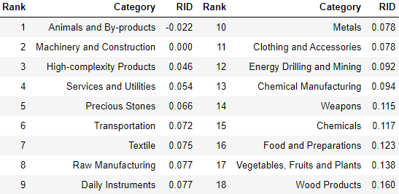

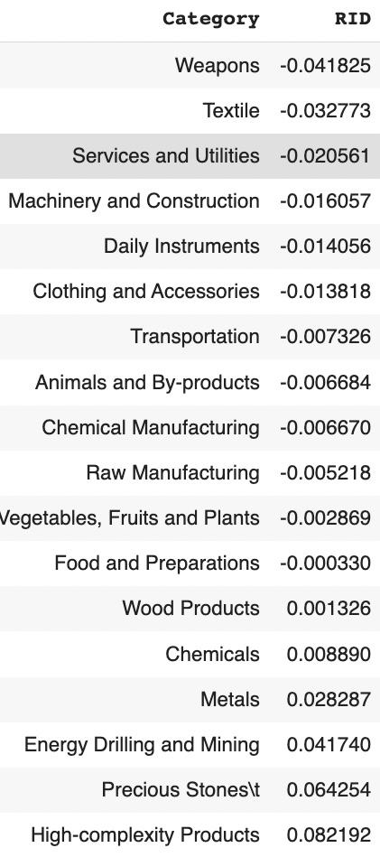

Tables 2a and 2b: Realized Industry Development (RID) of Egypt (2018 above; 2021 below)

3.3 Regional and Global Comparison
Tables 3 and 4 below summarize how the production strategy adopted by Egypt in 2018 compares with leading economies and a selected group of emerging economies in the world, as measured in RID. It can be directly observed that Egypt focused on products with a lower complexity level when compared against leading economies such as the United States and Germany, which gave a considerable level of attention to more advanced product groups such as clothing, services and utilities, and chemical manufacturing.

Ranking | France | The United States | Germany
1 | High-complexity Products | Services and Utilities | High-complexity Products
2 | Chemical Manufacturing | Weapons | Transportation
3 | Daily Instruments | Raw Manufacturing | Wood Products
4 | Animals and By-products | Precious Stones | Metals
5 | Food and Preparations | Animals and By-products | Food and Preparations

Table 3: RID Comparison across Leading Economies

Ranking | China | South Korea | Singapore
1 | High-complexity Products | Transportation | Transportation
2 | Transportation | Textile | High-complexity Products
3 | Machinery and Construction | High-complexity Products | Precious Stones
4 | Energy Drilling and Mining | Chemical Manufacturing | Daily Instruments
5 | Daily Instruments | Machinery and Construction | Services and Utilities

Table 4: RID Comparison across Emerging Economies

Table 4 further examines Egypt’s development strategy against those of emerging economies on a global scale in 2018. Logically, emerging economies such as China, South Korea, Singapore, and India have devoted the majority of their efforts into intermediate industry groups, while developed economies like Egypt should have relied more on advanced industry groups. This trend holds true in general, regardless of the continent or the time period, and serves as an indicator for which phase of development a country is currently in as evaluated from its production strategy. Based on this standard, Egypt is indeed adopting a moderate but slightly out-of-phase strategy that seeks development in industry groups with a lower level of complexity than it should.

4. Product Space Design

4.1 Suggested Development Vector
As aforementioned, distance gives us an idea of how far each new product is from a country’s current mix of exports. As defined in Hausmann and Hidalgo (2009), distance is “the weighted proportion of products connected to goods p that country c is not exporting, i.e., MCP = 0.” Based on this definition, the distance between a country and any product that the country is currently exporting (i.e., the country is a significant exporter in the product as compared to the global average) is zero. Similarly, opportunity gain quantifies the contribution of a new product in terms of opening up the doors to more and more complex products. Intuitively, a product that a country is currently exporting (i.e., MCP = 1) has an opportunity gain of zero. An unreasonable investment in a certain product p would lead to a relative decrement in the export of more profitable products, and therefore lead to a negative opportunity gain for product p. The opportunity gain is not the only estimator of a country’s level of economic development. However, among countries with comparable economic strength, those with higher ECI, or in other words, more reasonable economic structures are often in better shape.

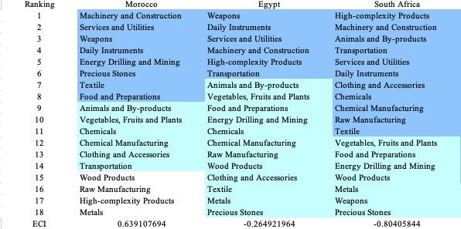
Table 5a: Opportunity Gain Ranking on a Regional Scale for 2013
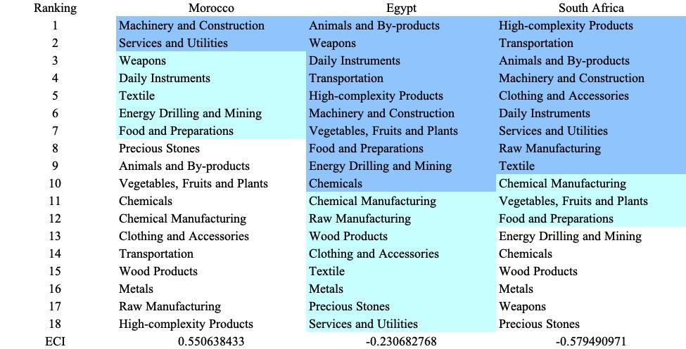

Table 5b: Opportunity Gain Ranking on a Regional Scale for 2018

Rank | Egypt | Tunisia | South Africa
1 | Animals and By-products | [Product Group *] | High-complexity Products
2 | Wood Products | Animals and By-products | Transportation
3 | Weapons | Services and Utilities | Chemicals
4 | Machinery and Construction | Precious Stones | Services and Utilities
5 | Transportation | Textile | Daily Instruments
6 | Chemicals | Vegetables, Fruits and Plants | Chemical Manufacturing
7 | Daily Instruments | Food and Preparations | Machinery and Construction
8 | Vegetables, Fruits and Plants | Chemicals | Raw Manufacturing
9 | Food and Preparations | Clothing and Accessories | Animals and By-products
10 | Energy Drilling and Mining | Transportation | Food and Preparations
11 | Chemical Manufacturing | Weapons | Textile
12 | Raw Manufacturing | Daily Instruments | Clothing and Accessories
13 | Clothing and Accessories | Energy Drilling and Mining | Wood Products
14 | Textile | Wood Products | Vegetables, Fruits and Plants
15 | Metals | Chemical Manufacturing | Energy Drilling and Mining
16 | Precious Stones | Machinery and Construction | Metals
17 | Services and Utilities | High-complexity Products | Weapons
18 | High-complexity Products | Raw Manufacturing | Precious Stones
ECI | 0.2740674 | -179.65 | 210.26
Table 5c. Opportunity Gain Ranking on a Comparable Scale (2021)

We define the ranking of opportunity gain for a country c as the Suggested Development Vector (SDV) of c. Tables 5a-5c and 6 summarize how the SDV of Egypt compares with a selected group of regional economies and leading economies in the world, with the industry groups ranked in decreasing order of significance. Dark blue indicates positive opportunity gain, light blue indicates zero opportunity gains, and white indicates negative opportunity gains. The result shows that leading countries barely have any industries with positive opportunity gain. In other words, those countries are already in the most stable and efficient economic structure. Without the necessity of economic transition, these countries merely need to maintain steady and balanced economic development. In contrast, developing countries have nearly half of the industries with positive opportunity gain and share common interests in industrial manufacturing and High-complexity Products industries. It can be concluded that Egypt shares the characteristics of developing countries, with a premature economic structure that leans towards basic to intermediate-level industries.

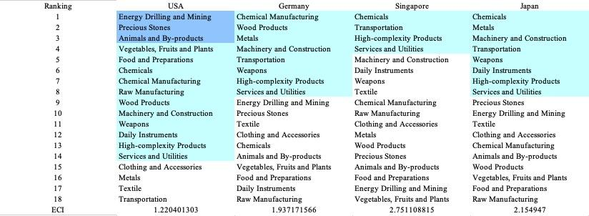

Table 6: Opportunity Gain Ranking on a Global Scale (2018)

4.2 Budgeted Industry Development Strategy and Interpretation

The optimal budgeted industry development strategy aims to solve the most efficient allocations under the budgeted constraint of different situations of heuristic total export growth. In order to obtain such an allocation portfolio, we formulate an optimization problem as follows:



where k(x) is the second largest eigenvector of $M_{CC'}$ after adding $x$ to the original export vector, C is the country that we are interested in, P is the product space, and B is the heuristic budget.

If we can solve this problem, then we can know what the largest ECI that a country can improve to. Accordingly, the optimal solution $x*$ that we obtain here is exactly our optimal allocation. However, the biggest problem is that the objective function is not convex. Therefore, we cannot apply the classical tools for convex optimization on this problem. In order to solve this problem, our idea is to use a greedy algorithm. The way that we apply the greedy algorithm is that firstly we separate the total budget into k equal parts, and then for the first equal part, we try to search for the product that can optimize our objective function by iterating through each $p∈P$. After we find the optimal product p for this equal part, we add the amount back to the export value of this product p and update the ECI for this country. If we observe that ECI does not change after iterating all the products, then we can add up one more equal part to invest. Until we find there is an ECI increment, we add the amount now to that product. The rest of the equal parts can be done in the same way.

However, as is known to all, greedy algorithm is a kind of local search algorithm, which is pretty possible to run into a local minimum. Therefore, for local search algorithms, one typical way to keep it away from the local minimum is to enhance the vision of the algorithm by looking more steps forward. In our setting, whenever we obtain an increment of ECI, we mark down the required amount of export growth. Simultaneously, we continue searching for the next ECI increment point, compare the ratios of these two possibilities, and pick the largest one. The ratio is defined as follows:


where ${ECI}_{p}$ is just the ECI of the country after adding some amount of export increment to product $p$, which is exactly the amount that is able to make ECI change. Also, we can express it in the way of $||$$x_{p}-x_{0}$${||}_{1}$.

In this way, we can obtain a further sighted greedy algorithm. Also, the number of parts that we would like to separate the budget into also matters. In order to solve this problem, we added a stabilizer on top of the enhanced greedy algorithm, by running the algorithm for different number of parts and selecting the portfolio with the largest ECI increment and the most complex economic structure.

Besides, it is quite common that there is a surplus for the budget. To deal with the surplus, we just add it to the product which needs the least amount of dollar to make $M_{cp}$ = 1, (i.e., the smallest amount of required export increase).

Economic Panel:
Figures 4a-4c show an economic panel for Egypt in 2013, 2018, and 2021. We can see that for different percentages of heuristic total export growth, the ECIs of Egypt actually have different increments.

Firstly, a pie chart is used to show the percentage of each product in the optimal portfolio. The number located in the center of the circle denotes the heuristic growth of total export, which is also our budget. For example, for the first pie chart below, it shows we should allocate 25% for Food and Preparations, Animals and By-products, and Chemicals. In addition, we should allocate 12.5% for Raw Manufacturing and Chemical Manufacturing. The line graph below the pie charts shows how the ECI changes during the searching process of the greedy algorithm. For example, in the last pie chart, we can see there are three components, but there are four increments in the last line chart. That is just because many equalized amounts have been invested in High-complexity products. The blue table is just for numerical explanation of the pie charts.

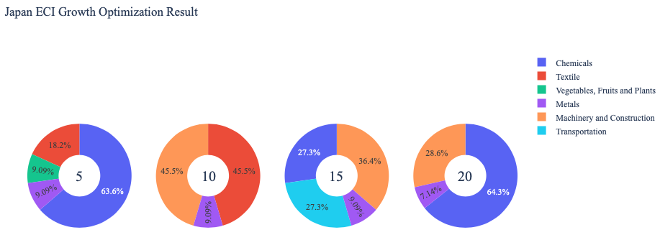
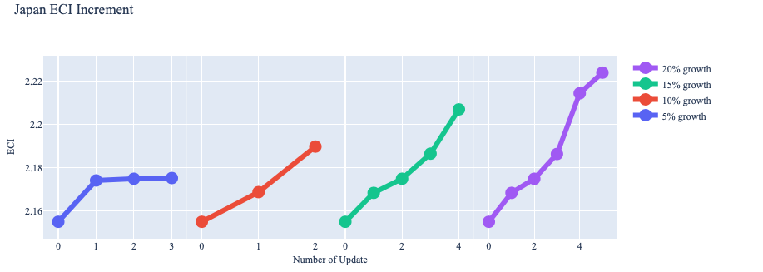
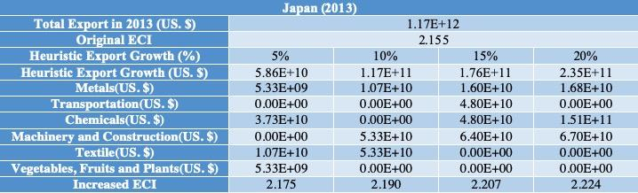

Interpretation:

Below is the economic panel for Egypt in 2013. We can see that for different percentages of heuristic total export growth, the ECI of Egypt will have a different amount of increments. From all the four graphs, we see that Egypt already obtains some great increment in terms of ECI. For the case of 5 percent export growth, Services and Utilities account for the only increment in the first line graph. For the case of a 10 percent increment, the Services Industry and Daily Instruments are the two industries that can boost the ECI optimally. For the case of 15 percent growth, the only difference to 10 percent growth is that Clothing can also contribute a small ECI increment. For the case of a 20 percent increment, the ECI is doubled because of a high proportion of allocation in the Machinery and Construction industry. However, since a 20 percent growth is hard to achieve, under a small amount of export growth budget, daily instruments as well as services and utilities products are the two that should be developed.

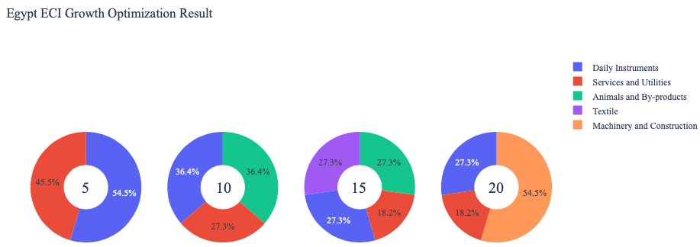

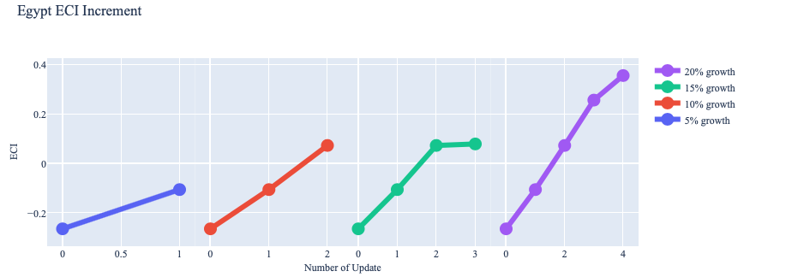
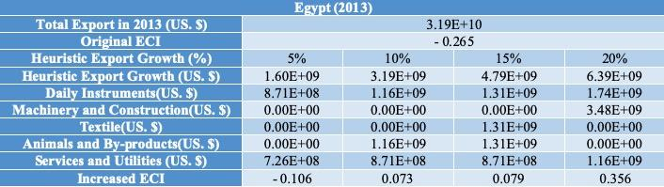

Following is the optimization result of Egypt based on export data in 2018. We can see that for different percentages of heuristic total export growth, the ECI growth pattern of Egypt is pretty similar to the one in 2013. For the case of 5 and 10 percent export growth, daily instrument product stimulate a small amount of ECI increment. For the case of 15 percent growth, the only difference to 10 percent growth is that nvestment in Machinery and Construction can bring a significant ECI increment. For the case of a 20 percent increment, the ECI is doubled because of a high proportion of allocation in the Machinery and Construction industry. Therefore, for future strategy, if the estimated export growth is low, Egypt should prioritize products of Daily Instruments. If the estimate is high, we should prioritize Machinery and Construction, and then Daily Instruments.

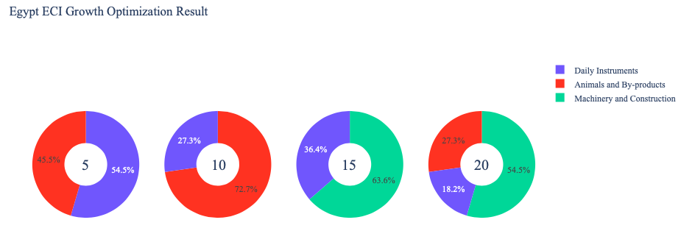
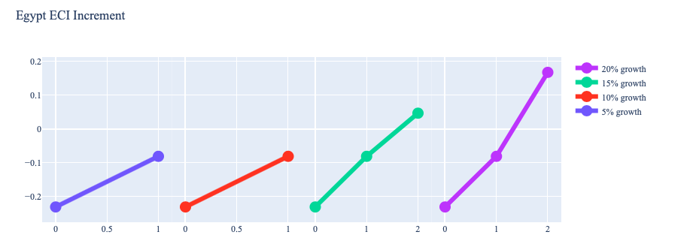

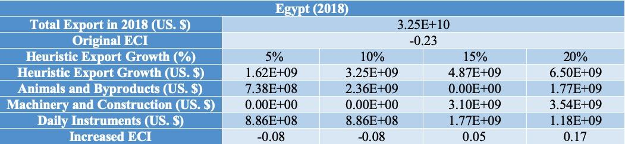

To compare with the performance in 2013 and 2018, we also re-examine suggested strategies for 2021. For 2021, a 5 percent increase in export emphasizes Precious Stones; a 10 percent increase emphasizes Textile; and both 15 and 20 percent again emphasize Precious Stones. Precious Stones and Textile make their first major appearances as optimal development industries, suggesting a change in Egypt’s development path over the course of 2019-2021. A more detailed numerical representation of the portfolio for Egypt is shown in Table 8c.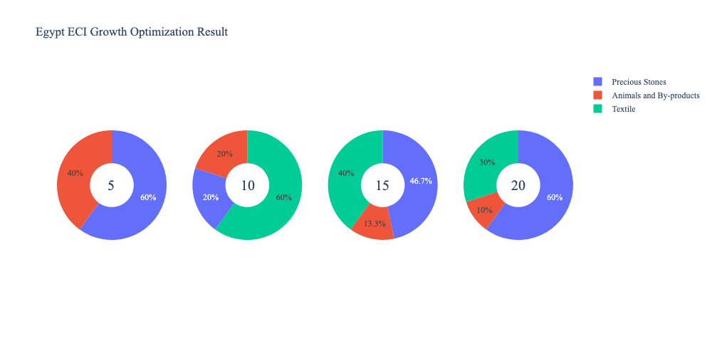
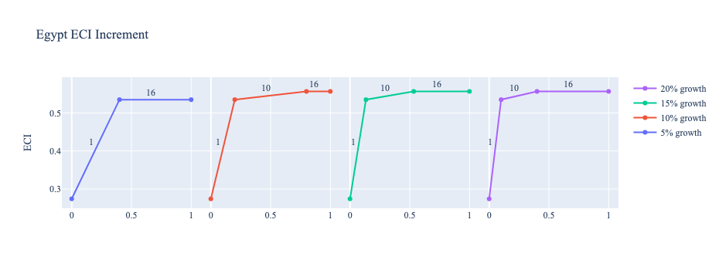

Egypt (2021)
Original ECI | 0.2740674
Heuristic Export Growth | 5% | 10% | 15% | 20%
Animals and By-products | 892958228.1 | 892958228.1 | 892958228.1 | 892958228.1
Textile | 0 | 2678874684 | 2678874684 | 2678874684
Precious Stones | 1339437342 | 892958228.1 | 3125353798 | 5357749368
Increased ECI | 0.5348483432 | 0.5565069164 | 0.5565069164 | 0.5565069164
Table 8c. Portfolio of Egypt (2021)

4.3 Sensitivity Analysis
In the following section, our broad aim is to understand how sensitive Egypt is to changes in exports in various industries. While the Economic Complexity Index has been shown to contain valuable information about the economic strength/capacity of a country, little has been said as to the stability of the measure itself. We seek to uncover the main drivers of stability under a country's ECI score and better understand longer-term projections for ECI growth. Additionally, gaining an intuition on the industries that are bolstering an economy and the industries that offer the greatest return per unit of investment is best done through visualization of industry-specific sensitivity.

ECI Sensitivity Graph
Firstly, in order to assess the effect particular industries have on each respective country, we developed ECI Sensitivity graphs. We use a shocking methodology to increment or decrement an industry’s export level by a certain percentage and recalculate the ECI, all else being equal. While freezing the export dynamics of the rest of the world and enacting an instantaneous shock in export for a particular industry and country may not reflect real-life dynamics, what it does offer us is an understanding of a country’s level of dependency on an industry in the context of ECI. The shocking is done in small percentage increments in order to smooth out the resulting curve. Additionally, a recurring theme one will see is that for most industries, a breaking point occurs where the ECI either jumps upwards or downwards, creating a hockey stick shape rather than a linear trend. While the inflection point may not be accurate in the context of real life, comparing the various inflection points across industries can give us valuable insight.
The graphs are formulated as follows: There are four ECI Sensitivity graphs. The first two represent data from 2021. The first chart shows positive shocking, in which export numbers are shocked upwards per industry. The X-axis is in terms of percentage shock per current dollar value of export. The Y-axis is the recalculated ECI level post-shocking. The second chart follows the same format, except the X-axis represents negative shocking. In other words, exports for each industry are decremented, and the ECI is accordingly recomputed. The following two sets of sensitivity graphs show the same results using 2018 and 2013 data, respectively. Below is an example of an ECI sensitivity graph.

Example 2018 (Incremental ECI Sensitivity)

4.3 Sensitivity Analysis Results and Interpretation

We examine Egypt's ECI Decremental and Incremental Sensitivity Charts for 2021. An increase in High-Complexity Products will lead to the highest change in ECI, followed by Precious Stones and Daily Instruments. The strong sensitivity effect of manipulating the Daily Instruments category remains consistent from previous years. For the negative shock cases, Energy Drilling and Mining becomes most impactful, remaining consistent with the previous years. The rest of the industries do not appear to have the same level of sensitivity.
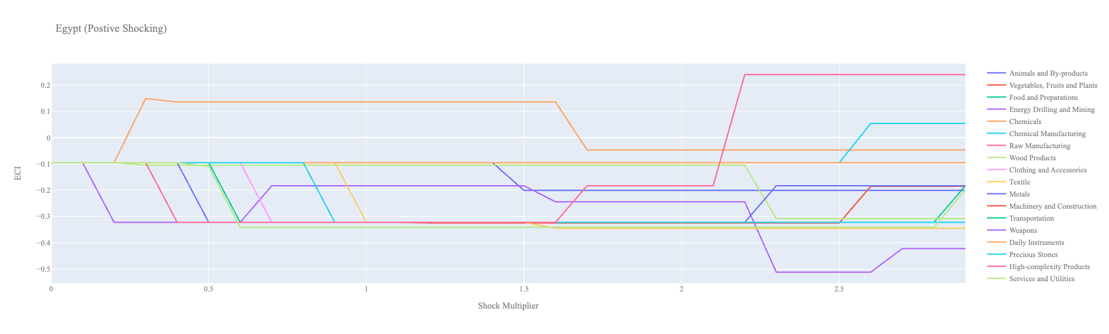
Egypt 2021 (Incremental ECI Sensitivity)
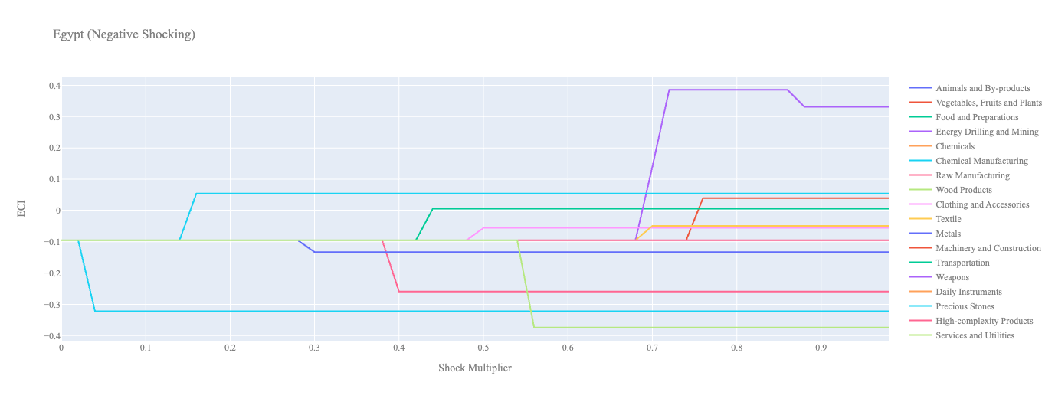
Egypt 2021 (Decremental ECI Sensitivity)

Below are Egypt’s 2018 ECI Sensitivity Charts. Firstly, in the positive chart, we notice immediately that similar to other less developed countries, Egypt’s ECI is not very sensitive to any industries. There seems to be quite a large increase in export needed for the ECI to increase. Daily Instruments in the orange is the industry that is able to bring the ECI closer to the positive range. However, more than a 100% increase in export in Daily Instruments export is needed for this improvement. Transportation and High Complexity Products both require a large increase in export levels for Egypt to see any improvement in ECI.

Next, we consider Egypt's 2018 Negative Shock chart. We can see that the negative shocking produces more interesting results. Energy Drilling seems to increase ECI when brought down 50%, which may indicate that this is not the best route to economic improvement while it may be necessary for short-term cash flow. Quite a few industries such as Precious Stones, Food and Preparations, Vegetables, Fruits and Plants actually increase ECI when their production is lowered, similar to Energy Drilling and Mining. This seems to suggest that Egypt may be overly invested in industries that may not lead to longer-run economic advancements.

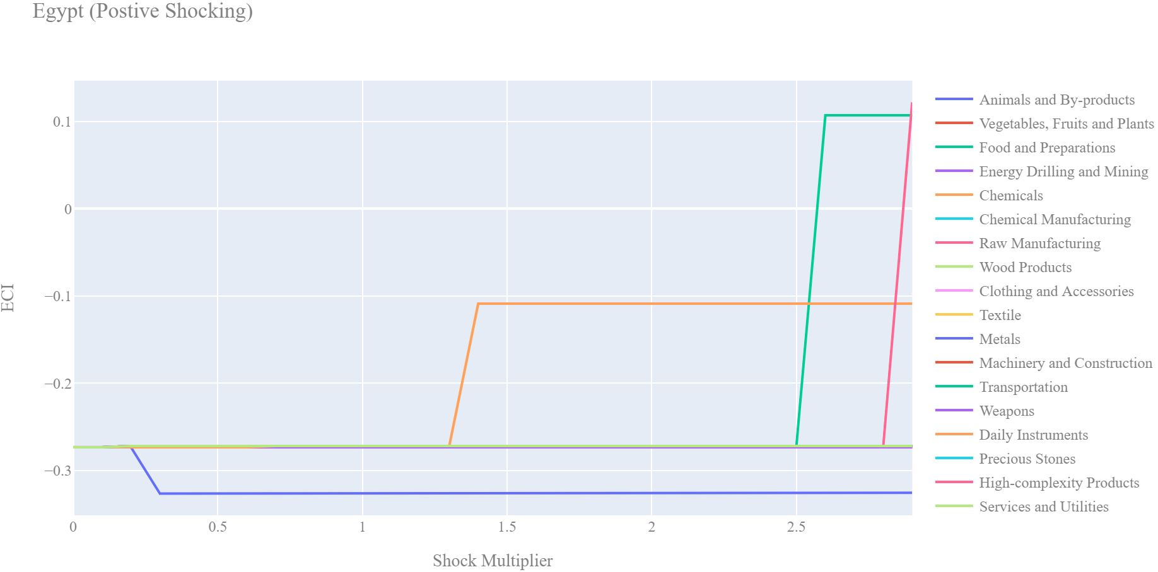
Egypt 2018 (Incremental ECI Sensitivity)

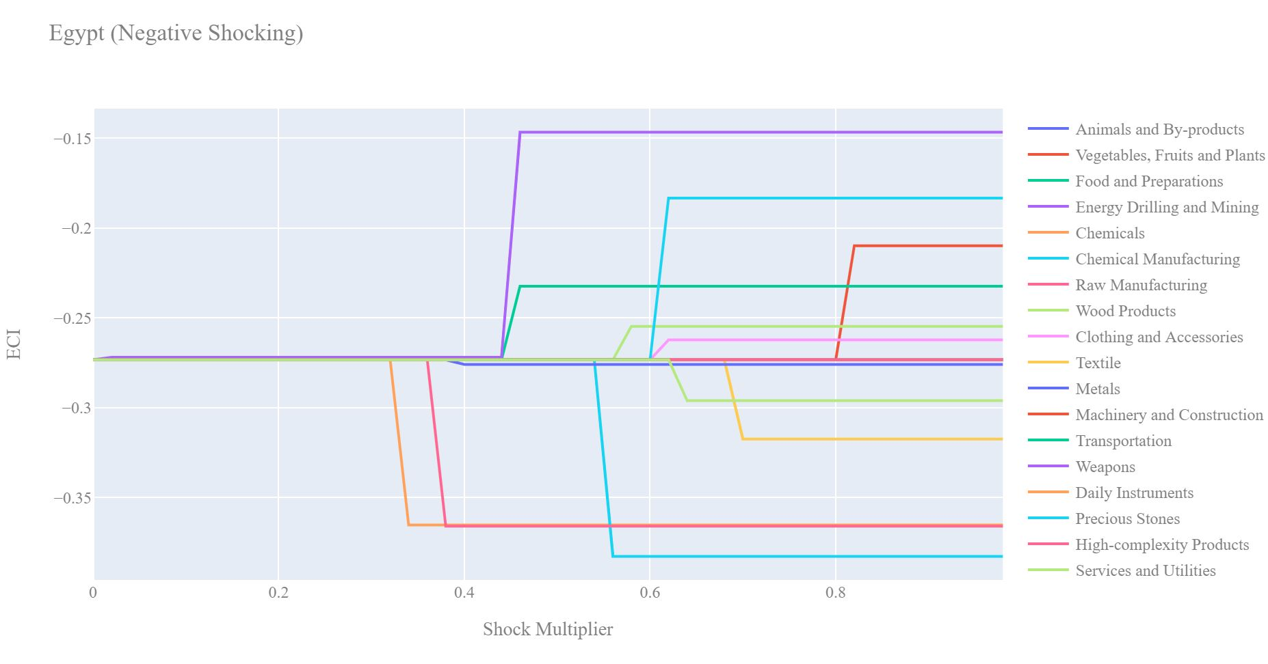
Egypt 2018 (Decremental ECI Sensitivity)

Next, we consider the 2013 ECI Sensitivity graphs. Again, positive shocking does not seem to significantly improve ECI. We see that small improvements are made with a few industries, but nothing is significant enough to put forth as an optimal industry to pursue. We do see that Daily Instruments in 2013 requires more than a 200% increase to be beneficial to Egypt, while as in 2018, only 100% is required. This may suggest that there is a positive opportunity to pursue the Daily Instruments industry currently and that becoming a significant player in this industry has become marginally less difficult.

In the 2013 negative shocking case, we see that industries such as Animal and By-products, Precious stones, and Energy Drilling improve ECI when exports are decreased. We can draw the same conclusion we made in the 2018 case. Again, Egypt is sensitive to major drawdowns in Chemicals, Chemical Manufacturing, and Raw Manufacturing.

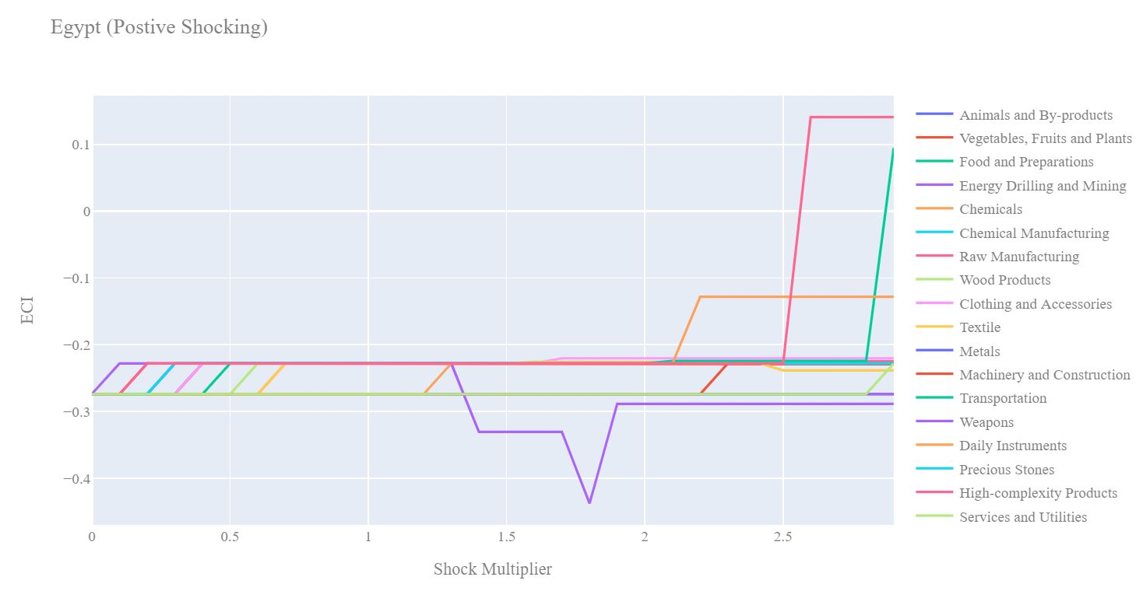
Egypt 2013 (Incremental ECI Sensitivity)
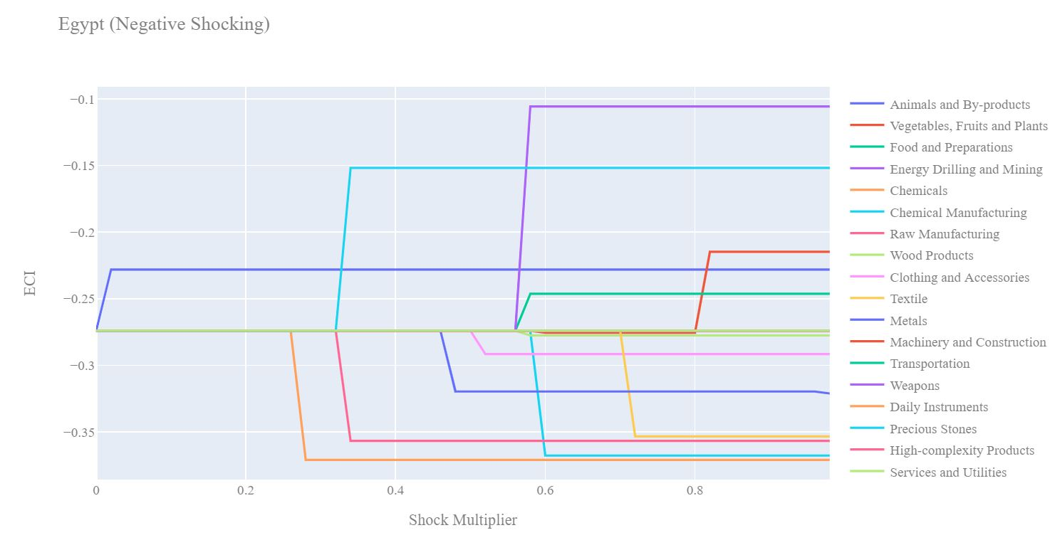
Egypt 2013 (Decremental ECI Sensitivity)

5. Macro-level Predictions

5.1 Structural Optimality Index
Indeed, such a choice of prioritization has proven to be a significant factor in deciding the economic outcomes of countries. In order to quantitatively evaluate how effective our development strategies are and how deviations from the suggested developmental path will lead to suboptimal growth results, we define the measure – Structural Optimality Index (SOI) – on a country level as the Adjusted R-Square obtained from regressing the country’s realized industry development over the suggested development strategy. Both strategies are quantified in nature, with the realized development represented by export increase in every major industry group and the suggested development strategy represented by the opportunity gains of developing the corresponding industry groups as calculated in previous sections. The adjusted R-square from the regression thus provides us with a quantified measure of how the development path adopted by the country has fitted with/differed from calculations on a complexity level.

After obtaining this measure for all countries in our database, we further regress countries’ five-year economic growth, which is defined as the net increase in GDP (USD), over their SOI. Figure 6 illustrates the regression output, which shows a strong positive correlation between countries’ SOI and their five-year GDP growth, significant at the 1% level and achieving an adjusted R² of 4.5%. In other words, the more a country develops as suggested by calculations on a complexity level, the better economic outcomes it achieves.

Table 18: OLS Regression Results
Dep. Variable: GDP | F-Statistic: 5.963
R²: 0.054 | Prob (F-Stat): 0.0163
Adj R²: 0.045 | No. Observations: 106

Figure 6: Regression of Five-year GDP Growth over SOI

5.2 SOI of Egypt and Its Implications
Egypt, for instance, has a moderate level of structural optimality as compared with its emerging peers. As the regression in Figure 7 suggests (the orange curve represents export increase and the blue curve stands for opportunity gain of the corresponding industry), Egypt demonstrates a decreased level of correlation with the suggested developmental path, having an adjusted R-square of around -3.0% in 2021 and 4.9% in 2018. Egypt ranks 79th among all countries in terms of SOI and has made an above-average rate of economic progress among its emerging peers from 2013 to 2021, which is consistent with the regression result in Figure 6. This shows a higher mismatch than emerging economies such as Turkey, where there is a high SOI of around 21.8% and there is a corresponding 5-year GDP growth of 36.7%, making it one of the faster-developing economies during the period. In sum, Egypt’s stable economic progress from 2013 to 2021 can be at least partially explained by a development strategy that demonstrates a considerable level of alignment with our suggested developmental path. Specifically, in 2019-2021, Egypt invested heavily in High Complexity Products, but it would have done better to focus on Energy Drilling and Mining, which is more in line with its suggested development path given its current ECI.
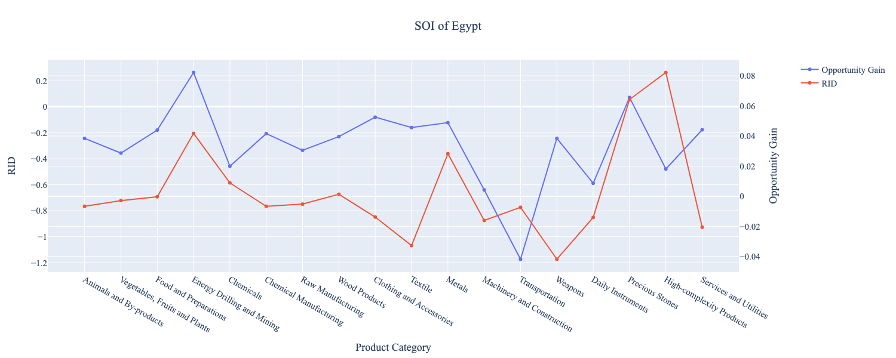
Figure 7a: SOI of Egypt (2019-2021)

In 2013-2018, Egypt invested heavily in the Machinery and Transportation industries, while it could have focused more on moderately complex industry groups such as Chemical Manufacturing.

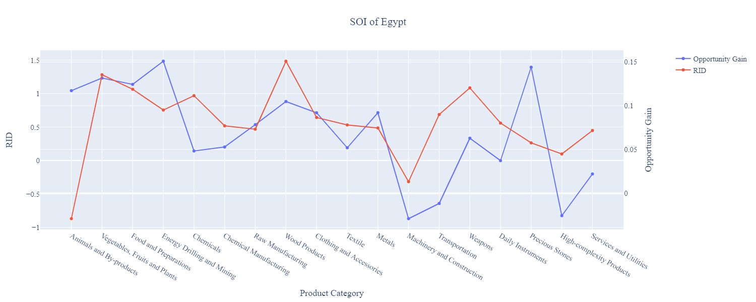

Figure 7b: SOI of Egypt (2013-2018)

6. Concluding Remarks

In conclusion, Egypt has demonstrated a moderate level of economic growth in terms of GDP during the period from 2013 to 2021, concurrent with a significant increase in ECI by 2021.

The level of economic progress during the period, we believe, can be partially explained through analysis of the economic and product complexity structure of Egypt on the industry group level. The product classification system we adopt allows us to measure the realized industry development for various industry groups and to observe that Egypt invested heavily in developing High Complexity Products towards the end of the period, in line with other fast-growing and developed economies around the globe.

Based on our analysis of the opportunity gain and a sensitivity analysis of major industry groups, Egypt can further its gains by focusing on Daily Instruments, Services and Utilities. We further note that Egypt has a slightly matched development strategy that indicates a low level of structural optimality on the complexity level, having an adjusted R-square of around -3.0% in 2021. Since a significant positive correlation exists between GDP growth and the structural optimality index of an economy as we define and calculate, Egypt indeed has a suboptimal growth experience as compared with fast-growing economies both on a regional scale and on a global scale, and has the potential to further its economic gains through industrial structure optimization as suggested in the paper.

References

Hausmann, R., Hidalgo, C., Bustos, S., Coscia, M., Chung, S., Jimenez, J., Simoes, A. and Yıldırım, M. (2007). The Atlas of Economic Complexity. [online] Atlas.cid.harvard.edu. Available at: http://atlas.cid.harvard.edu/.

Balassa, B., “The Purchasing Power Parity Doctrine - A Reapprais- al,” Journal of Political Economy 72, 584-596 (1964).

Feenstra, R.; Lipsey, R.; Deng, H.; Ma, A. & Mo, H. “World Trade Flows: 1962-2000” NBER working paper 11040. National Bureau of Economic Research, Cambridge MA (2005).

United Nations Commodity Trade Statistics Database (http://comtrade.un.org/db/), accessed in August 2019.

The World Economic Forum, “The global competitiveness report,” (various years).

Barro, R. & Lee, J-W. “A New Data Set of Educational Attainment in the World, 1950-2010,” NBER Working Paper No. 1590 (2010).

Kaufmann, D. & Kraay, A. “Governance Indicators: Where Are We, Where Should We Be Going?” Policy Research Working Paper 4370. Washington, DC: World Bank (2008).

Hanushek, E.A. & Woessmann, L. “The Role of Cognitive Skills in Economic Development,” Journal of Economic Literature 46(3), 607- 668 (2008).

https://www.imf.org/en/News/Articles/2021/07/14/na070621-egypt-overcoming-the-covid-shock-and-maintaining-growth

